create database October1;

go

use October1;

create table Products

(

Pid int primary key,

Pname varchar(50),

Price float,

Cid int

);

insert into Products values(11,'LUX',35,1);

insert into Products values(12,'RIN',20,1);

insert into Products values(13,'SUNSILK',75,2);

insert into Products values(14,'LOREAL',85,2);

insert into Products values(15,'LIRIL',25,1);

insert into Products values(16,'LIZOL',65,3);

insert into Products values(17,'HARPIC',75,3);

insert into Products values(18,'PONDS',65,4);

insert into Products values(19,'REXONA',29,1);

insert into Products values(20,'MARGO',23,1);

SELECT * FROM Products

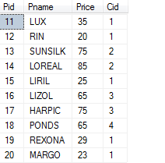

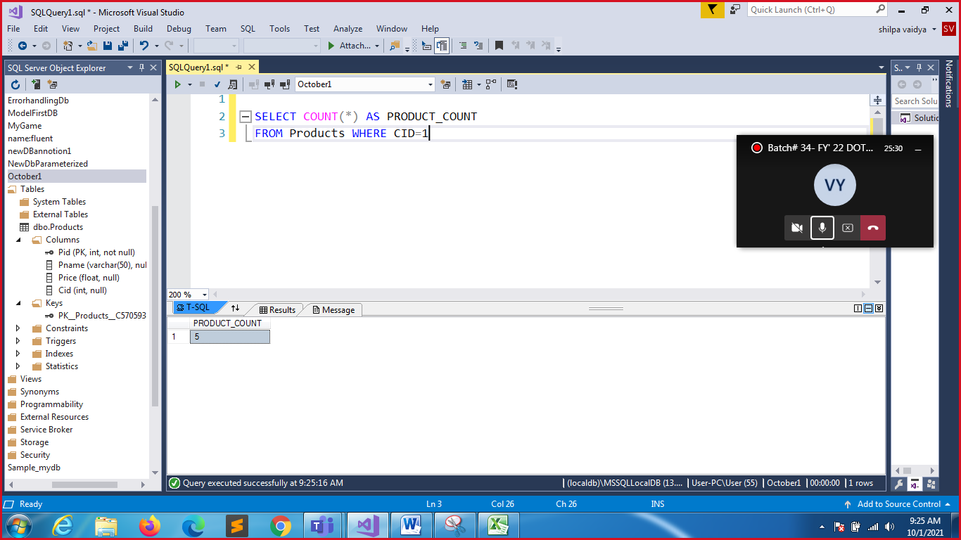

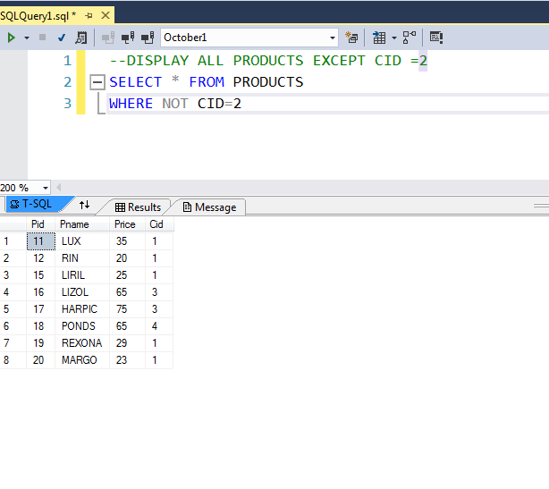

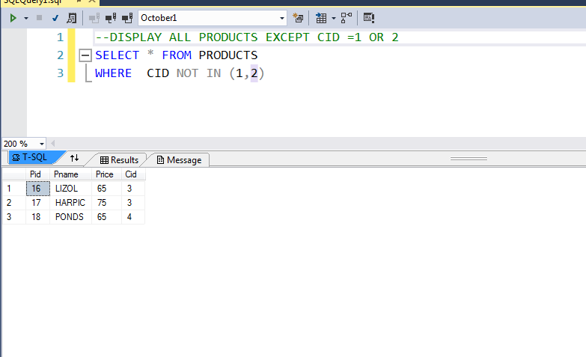

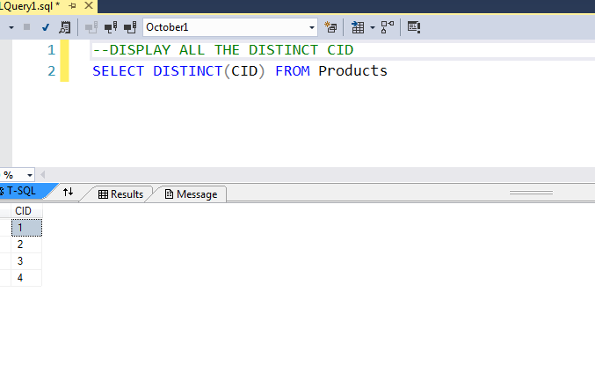

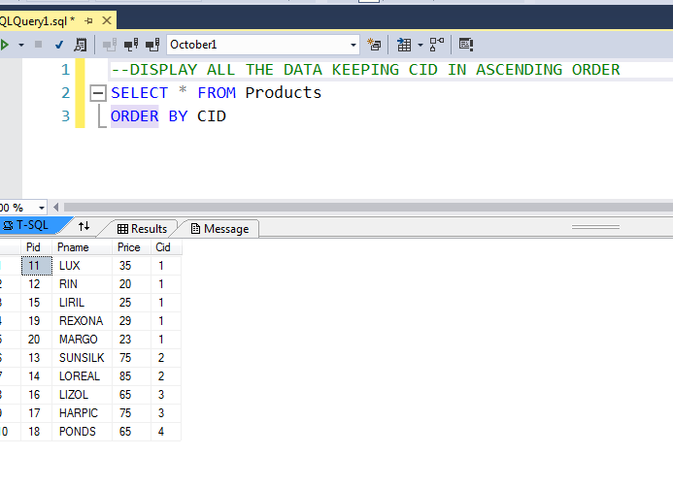

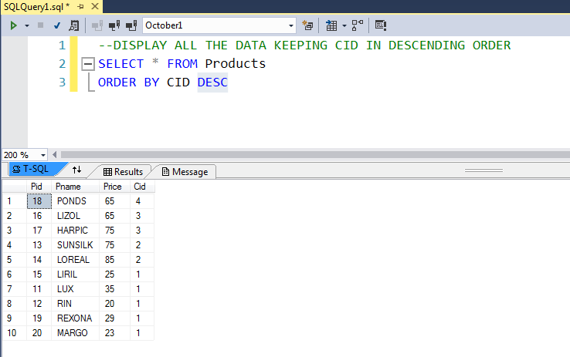

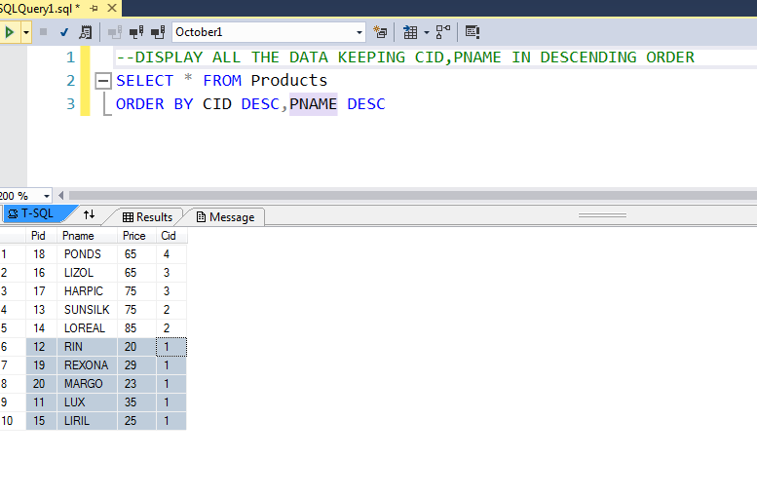

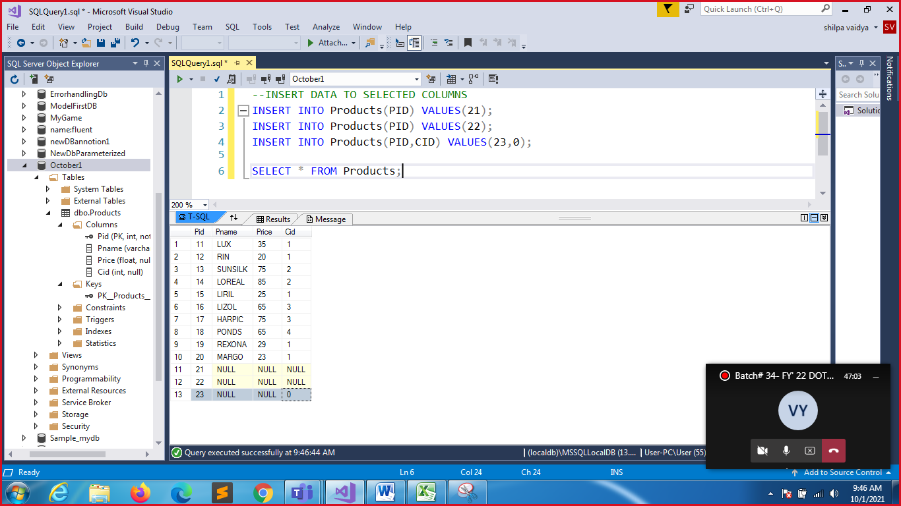

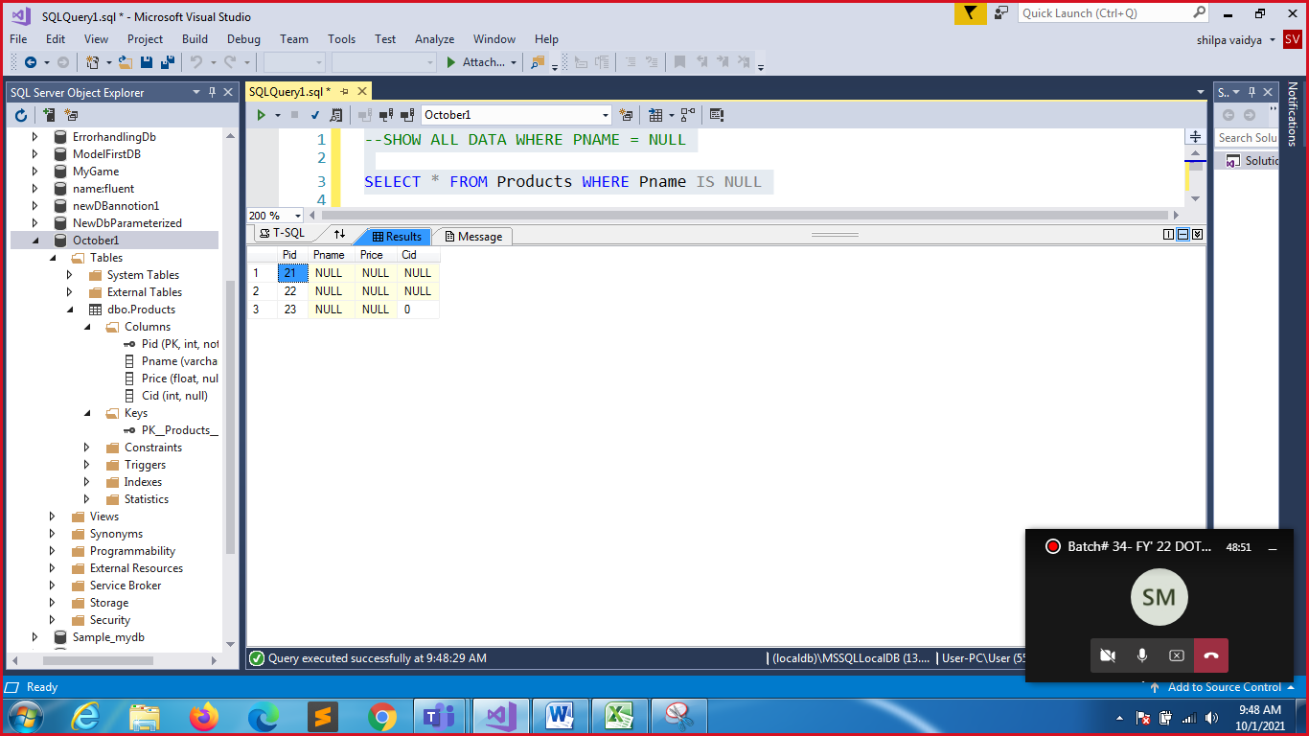

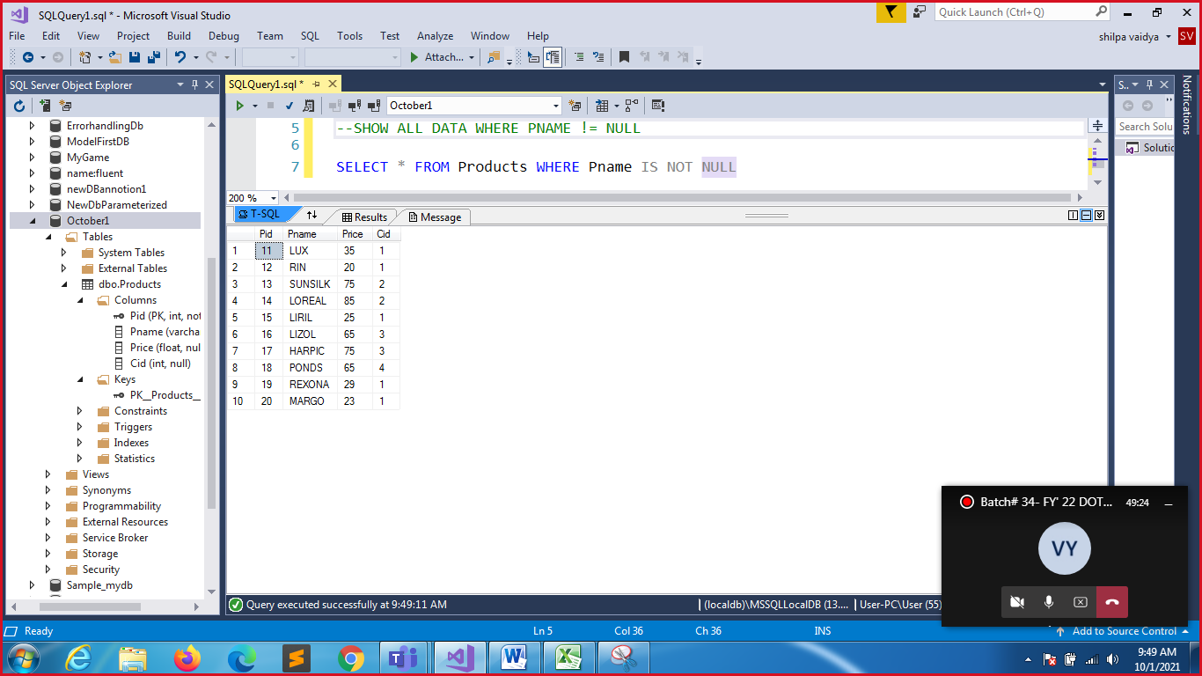

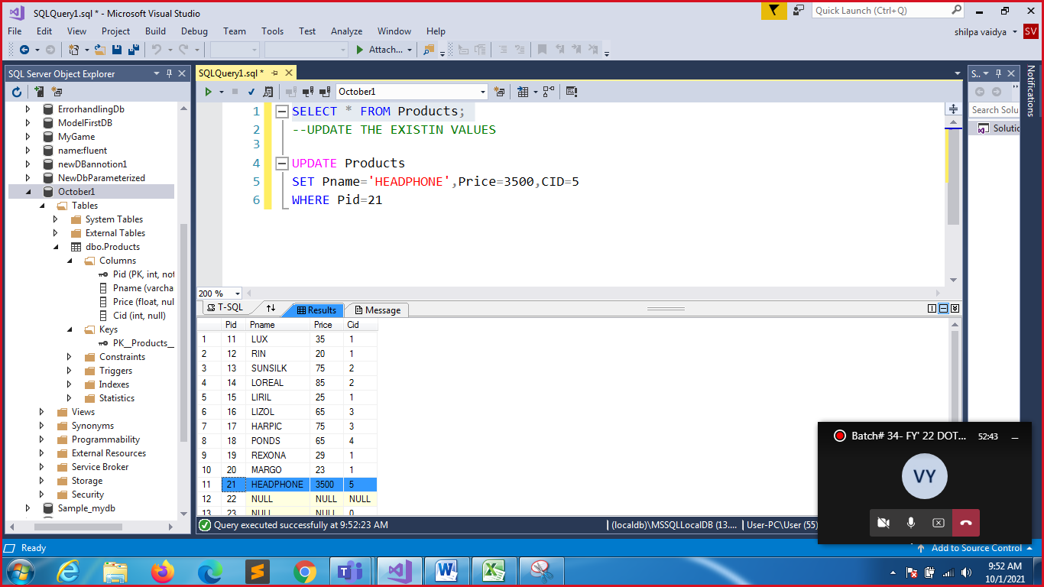

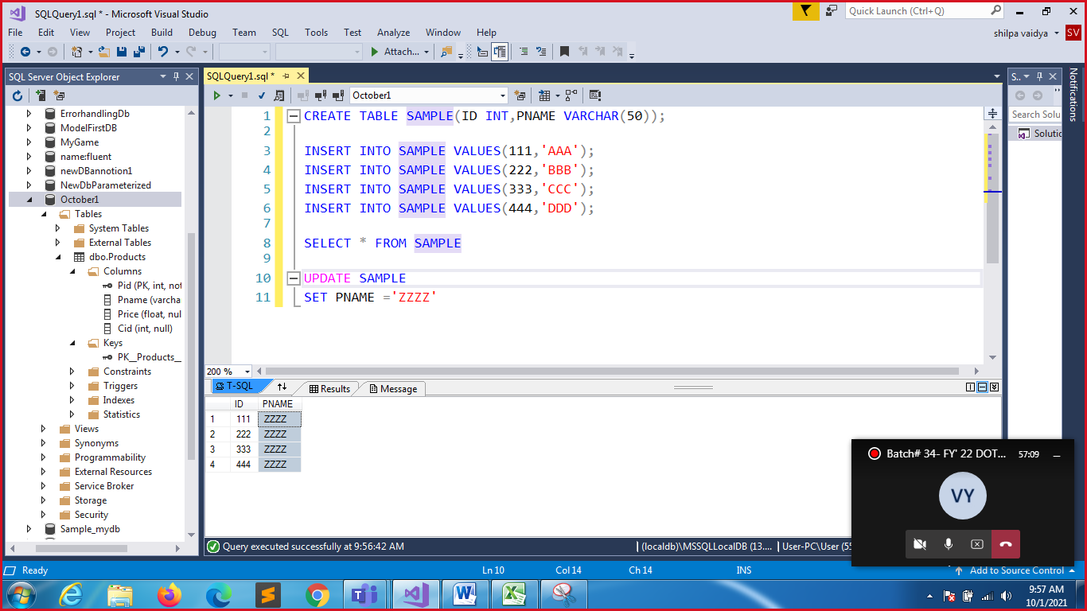

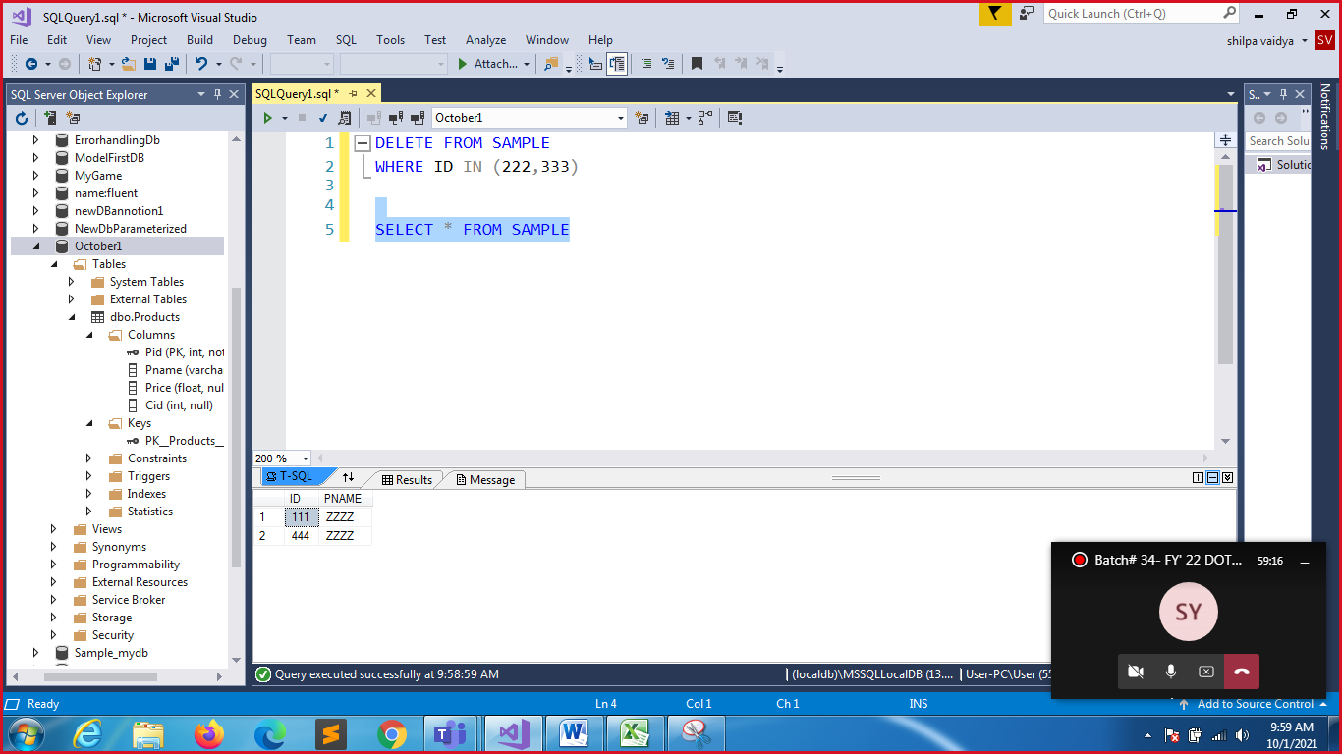

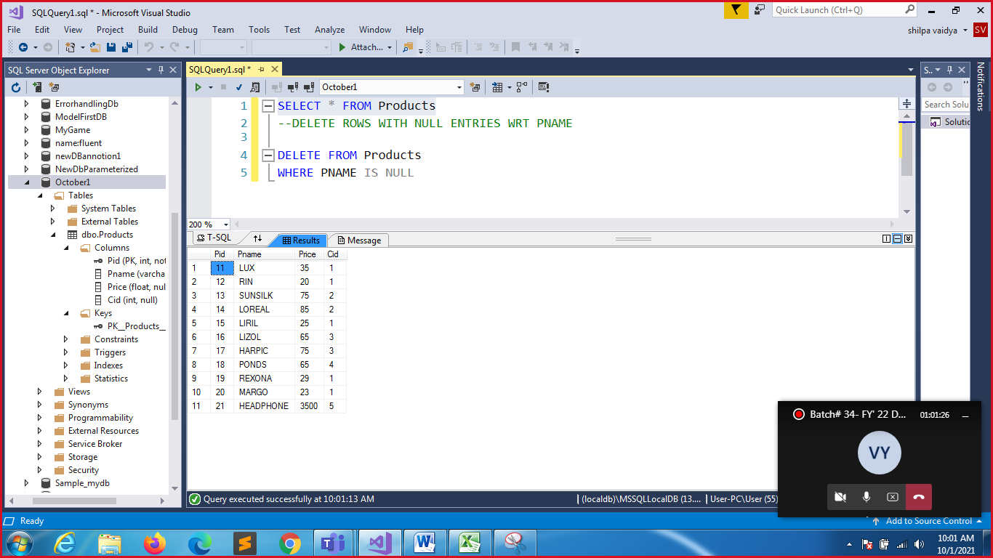

SELECT * FROM SAMPLE

--TRUNCATE SAMPLE

TRUNCATE TABLE SAMPLE

--DELETES THE TABLE FROM DATABASE

DROP TABLE SAMPLE

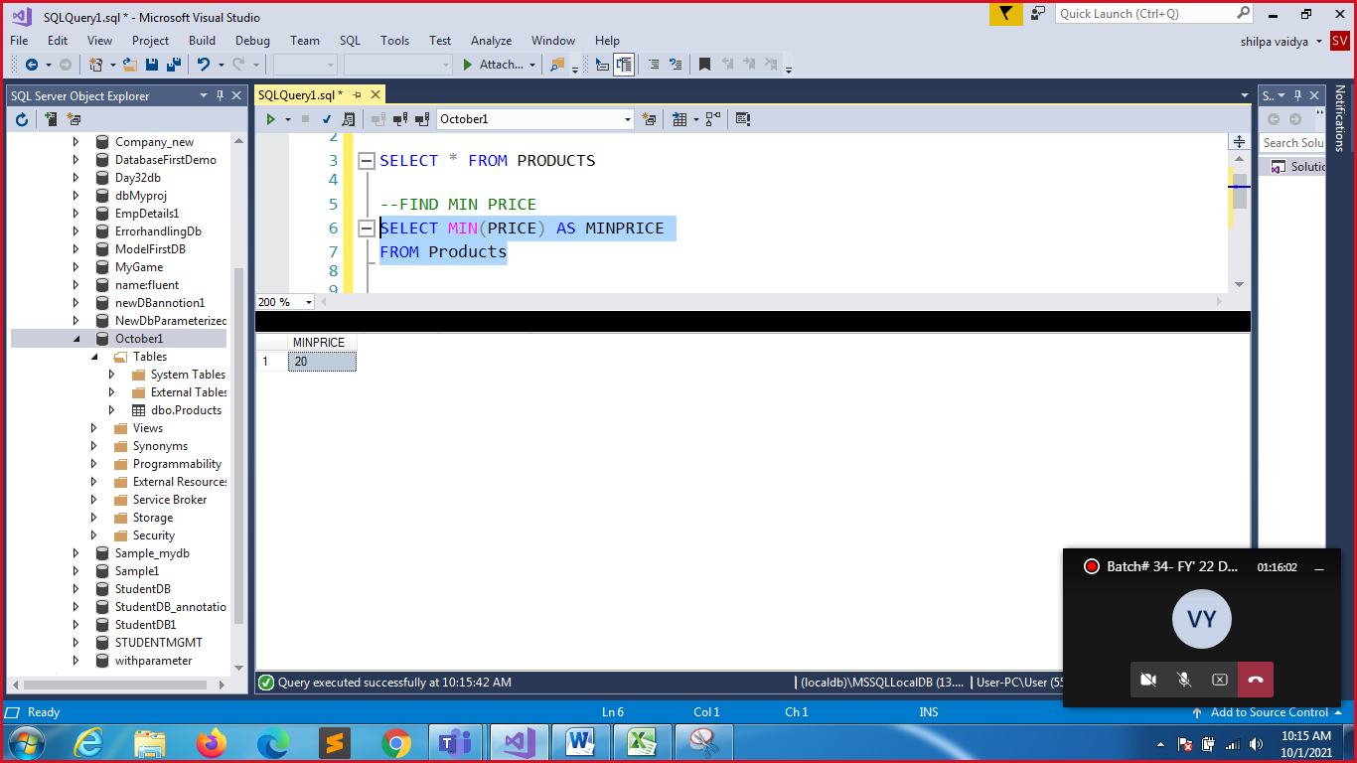

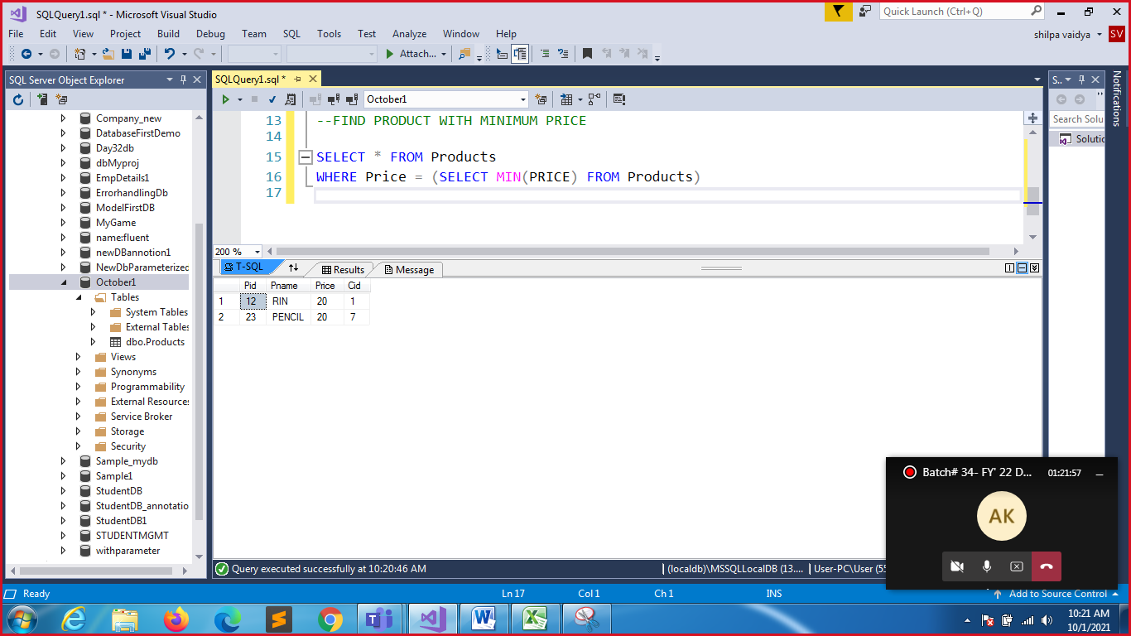

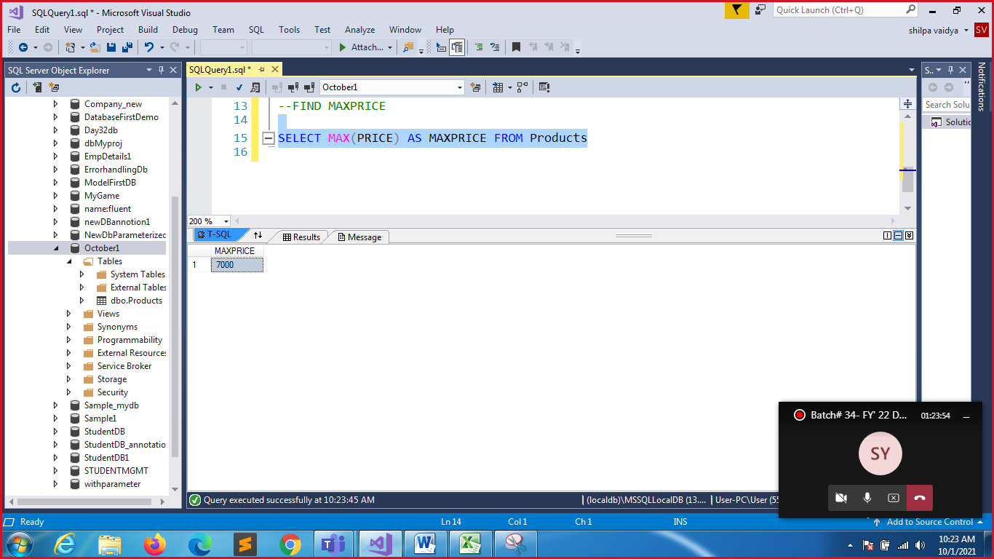

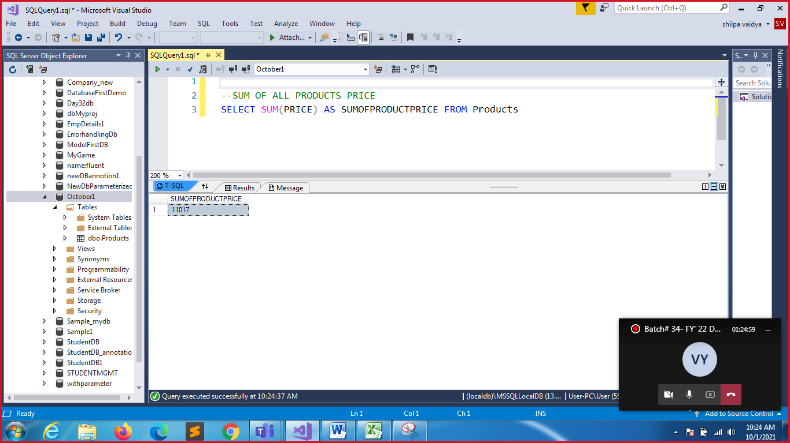

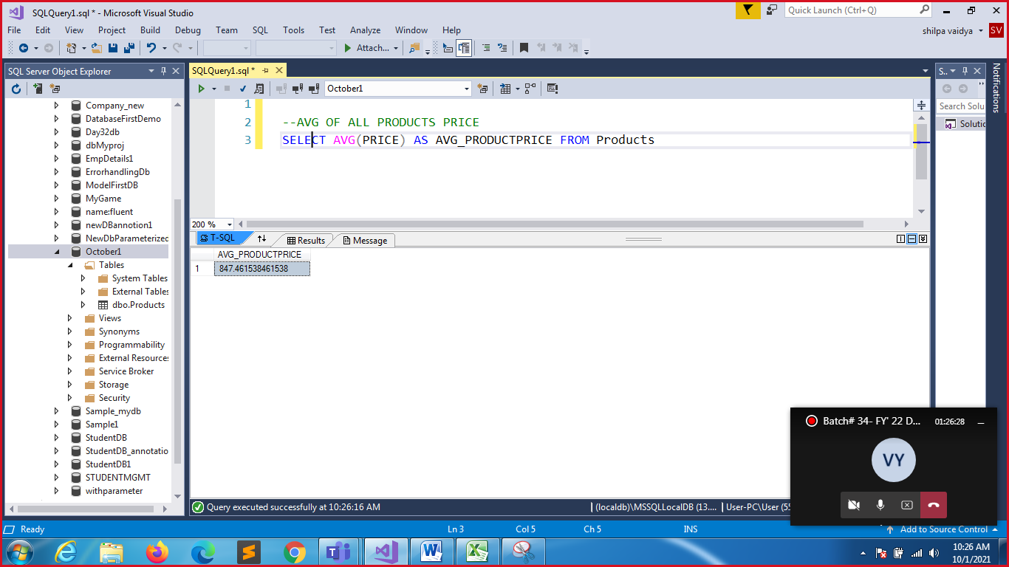

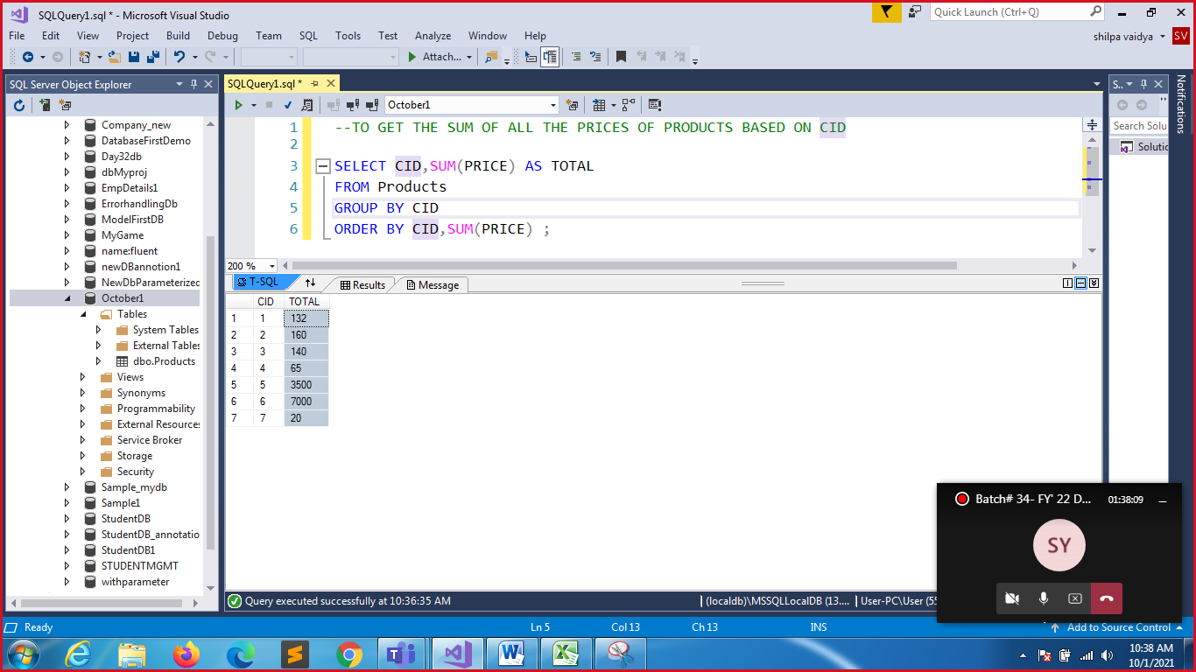

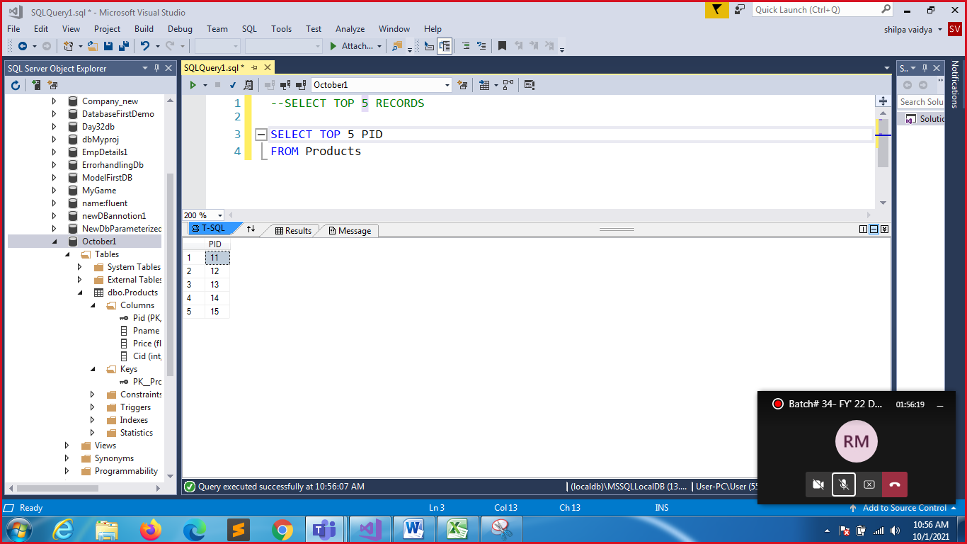

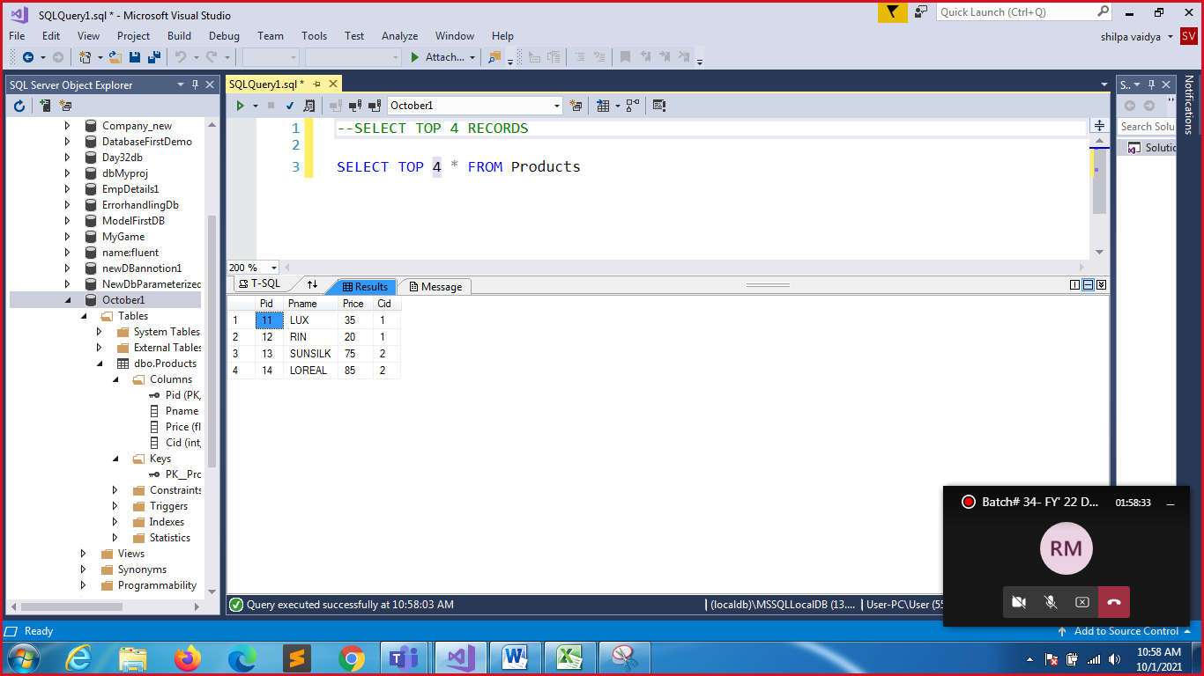

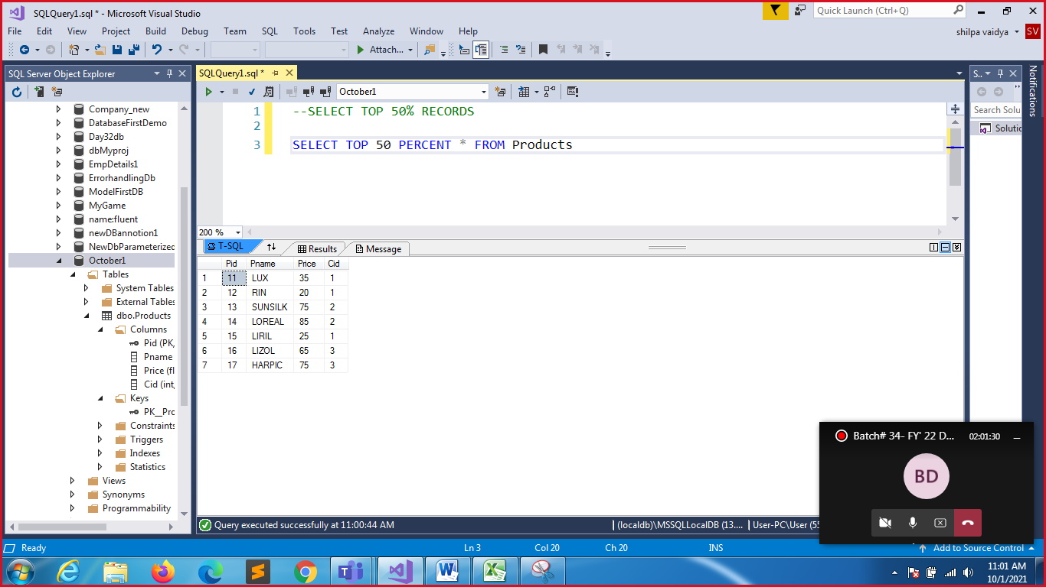

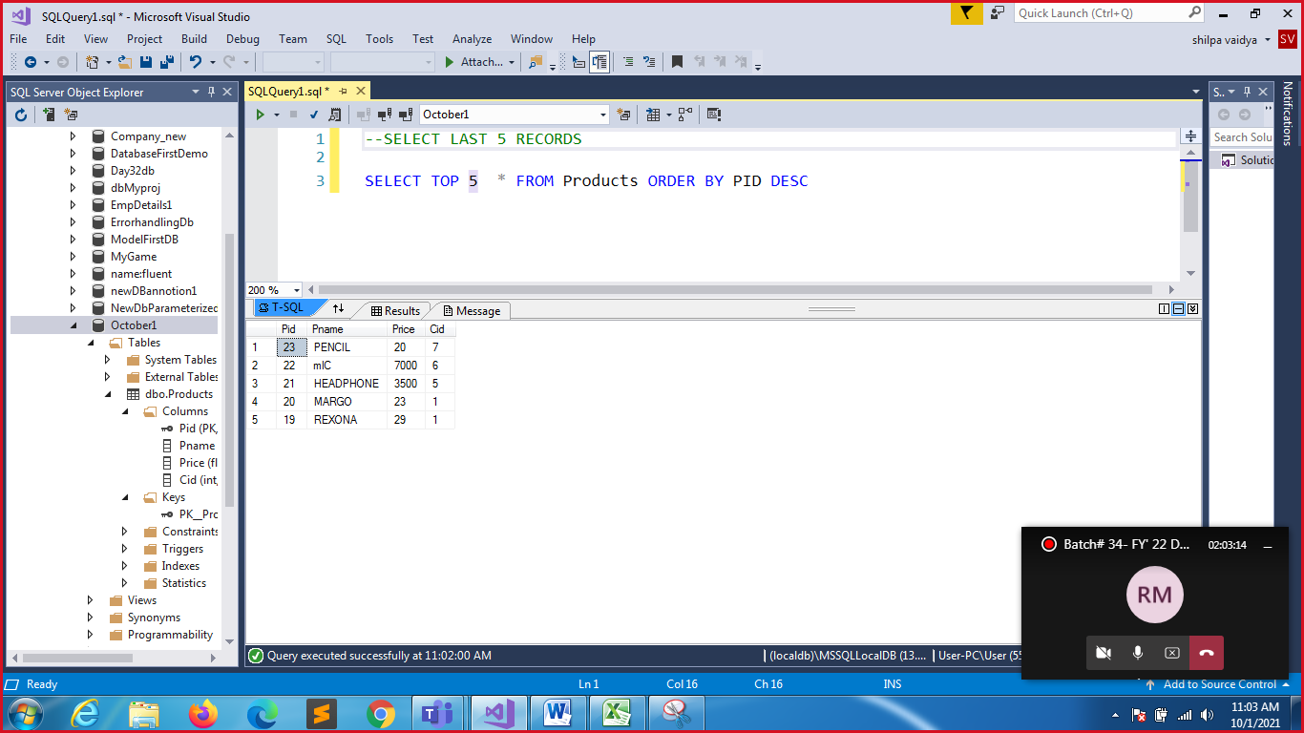

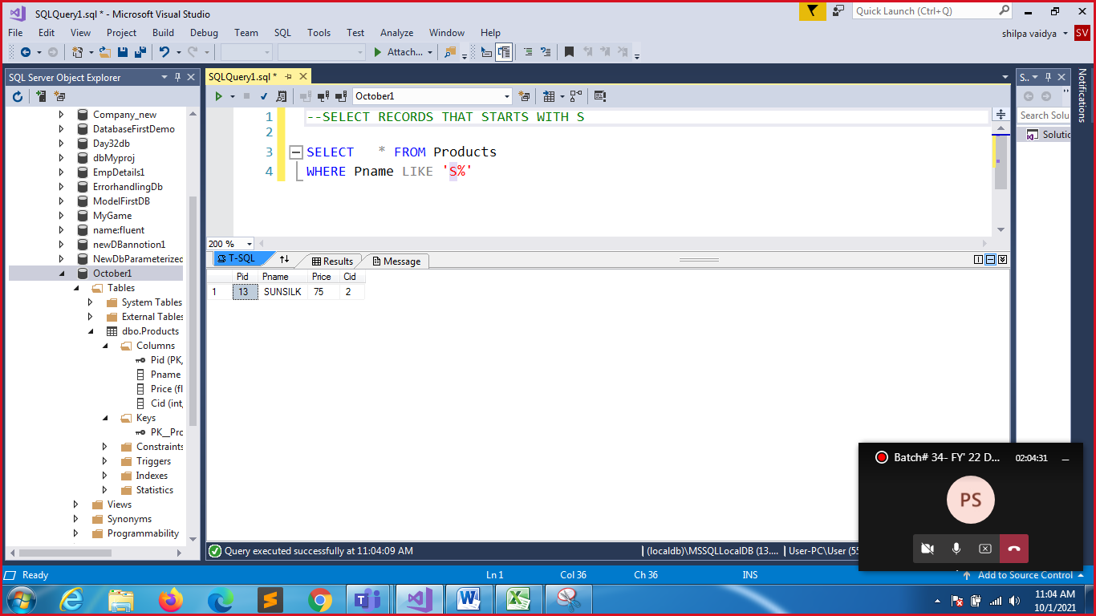

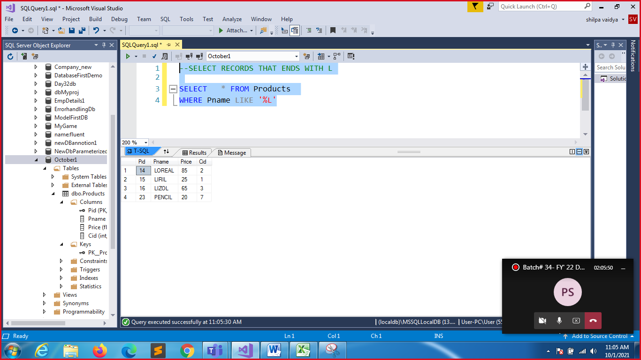

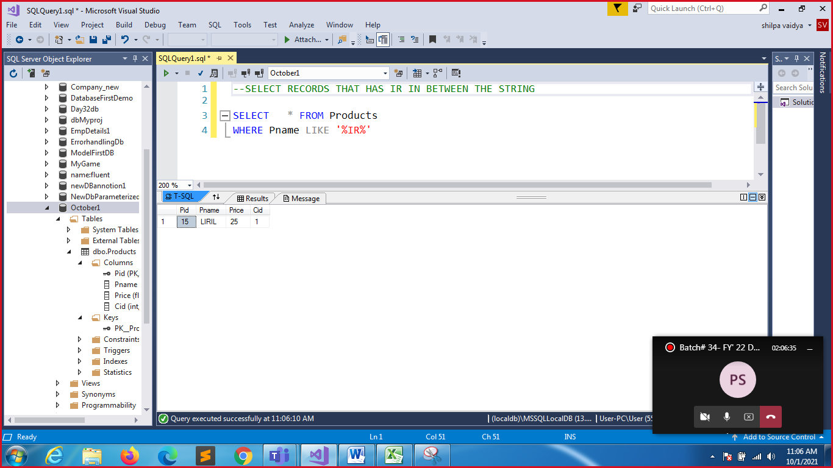

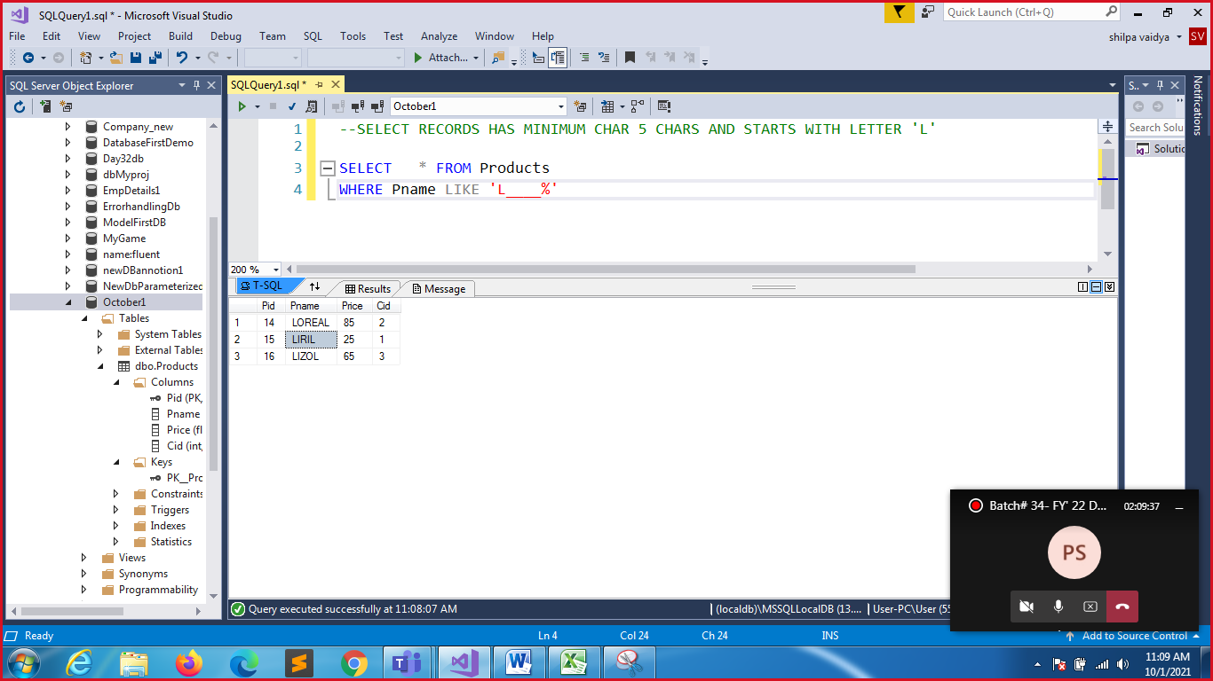

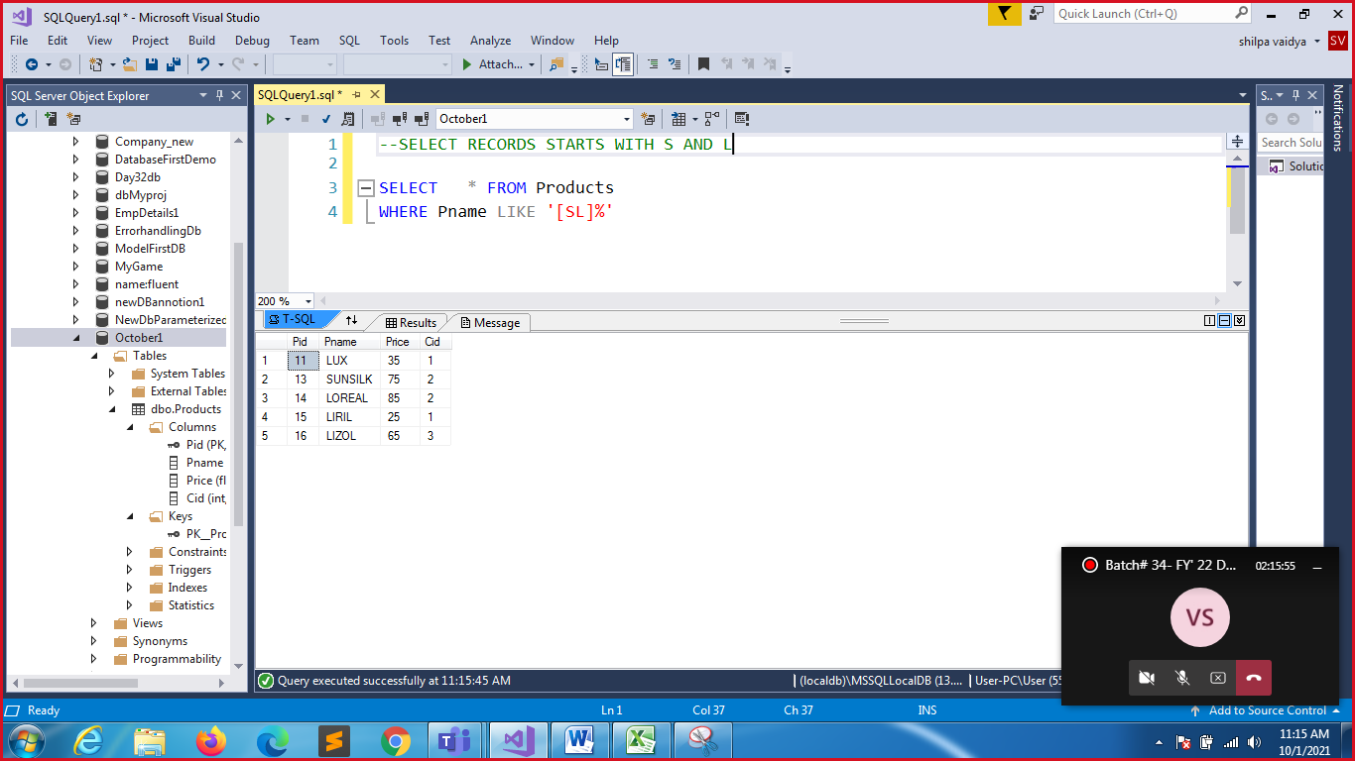

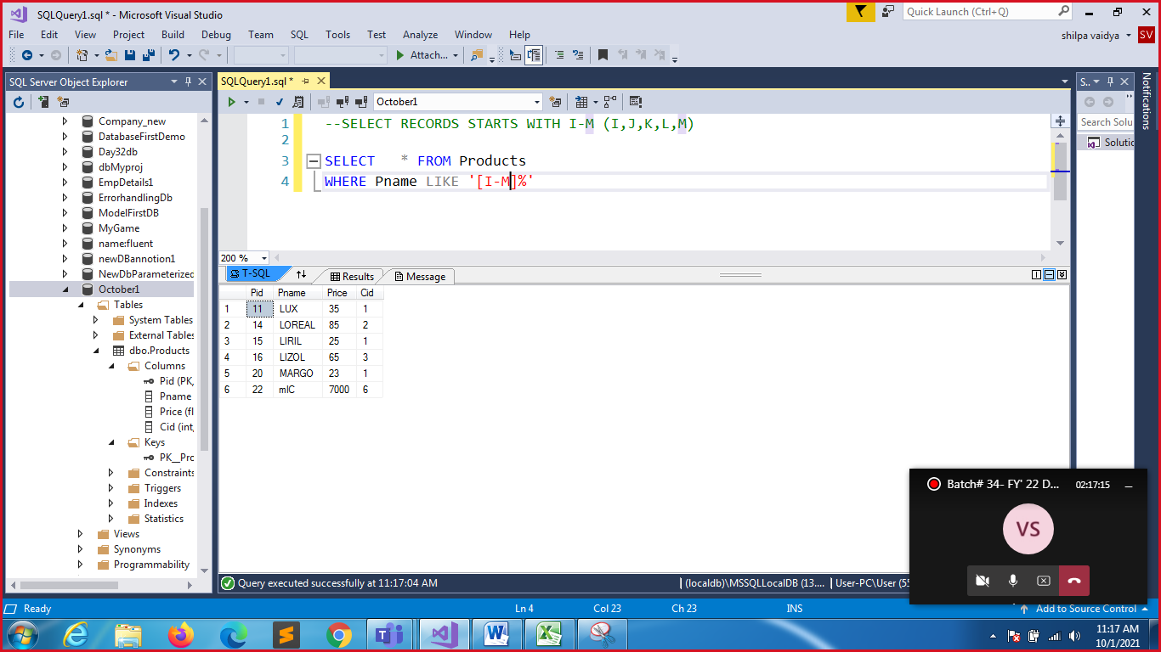

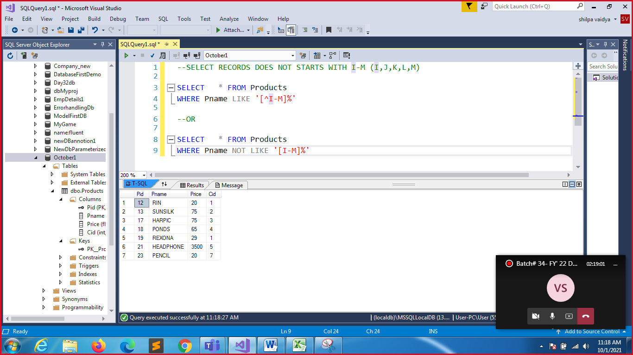

CREATE TABLE CATEGORIES

(

CID INT PRIMARY KEY,

CATNAME VARCHAR(50)

);

INSERT INTO CATEGORIES VALUES(1,'SOAP')

INSERT INTO CATEGORIES VALUES(2,'SHAMPOOS')

INSERT INTO CATEGORIES VALUES(3,'DISINFECTANTS')

INSERT INTO CATEGORIES VALUES(4,'CREAMS')

INSERT INTO CATEGORIES VALUES(5,'HEARING ACCESSORIES')

INSERT INTO CATEGORIES VALUES(6,'SPEAKING ACCESSORIES')

INSERT INTO CATEGORIES VALUES(7,'STATIONERY')

INSERT INTO CATEGORIES VALUES(8,'HOME APPLIANCE');

INSERT INTO CATEGORIES VALUES(9,'MOTORS');

SELECT * FROM CATEGORIES;

|  |  |
| --- | --- |
| CID | CATNAME |
| 1 | SOAP |
| 2 | SHAMPOOS |
| 3 | DISINFECTANTS |
| 4 | CREAMS |
| 5 | HEARING ACCESSORIES |
| 6 | SPEAKING ACCESSORIES |
| 7 | STATIONERY |
| 8 | HOME APPLIANCE |
| 9 | MOTORS |
|  |  |

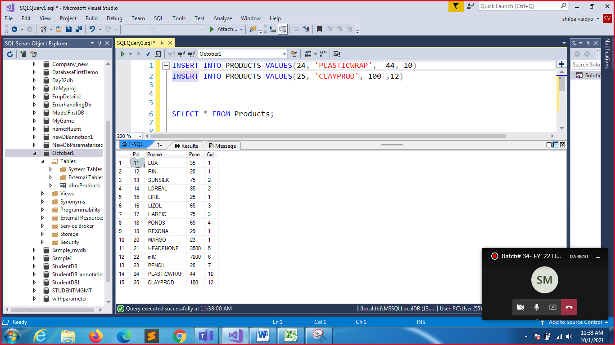

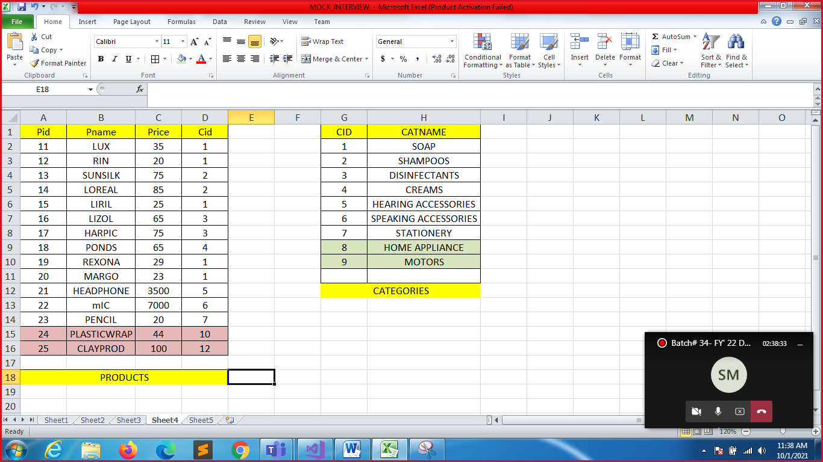

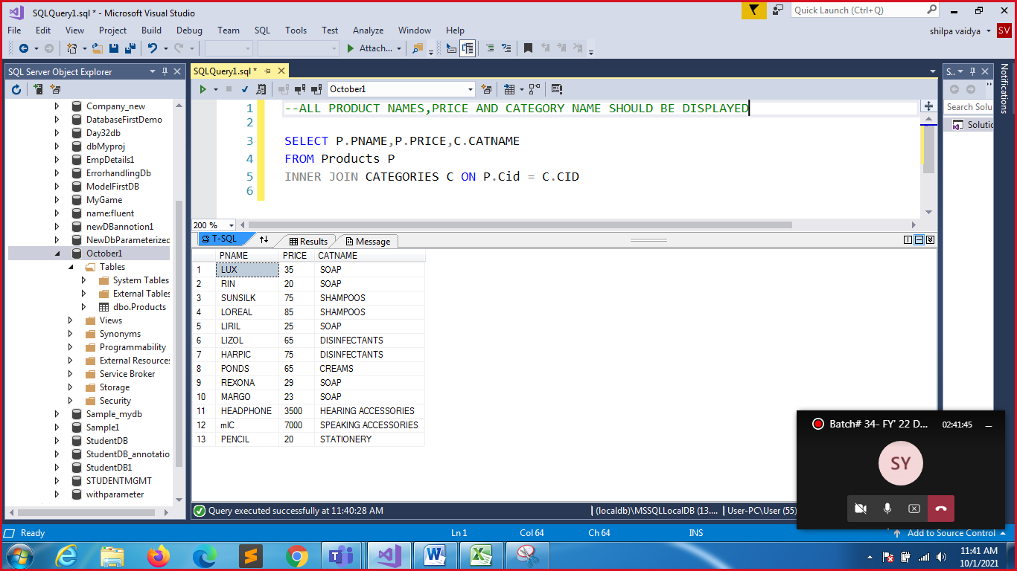

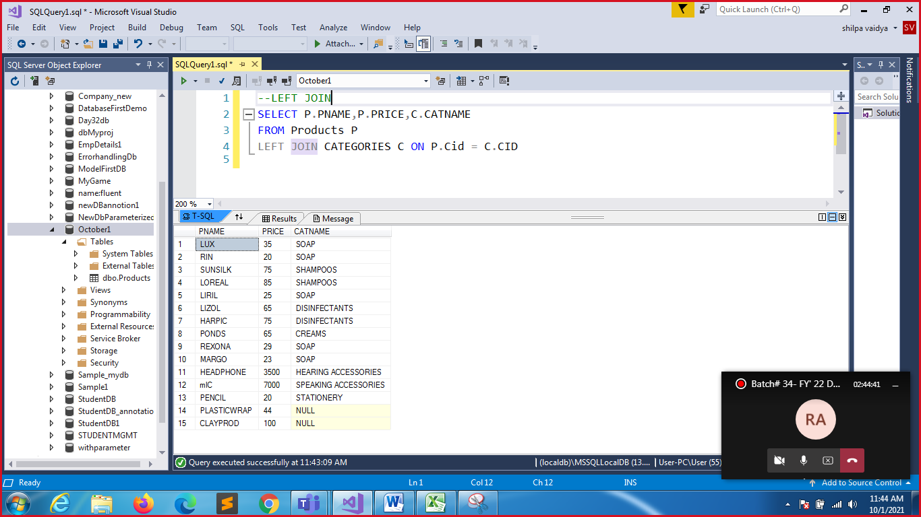

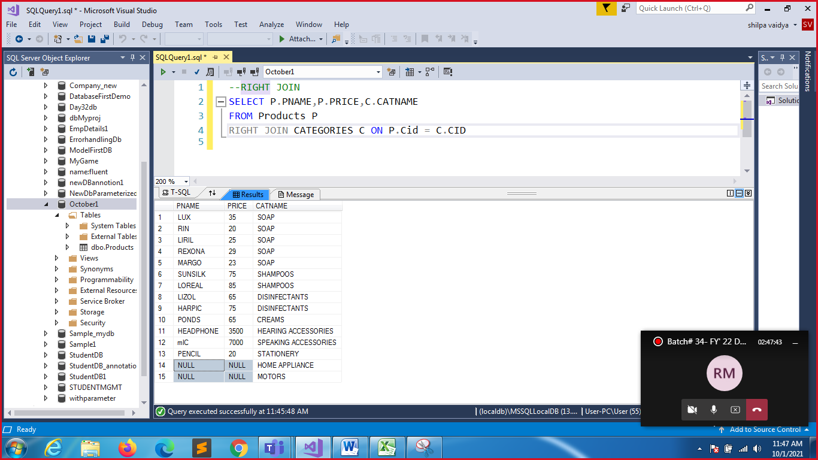

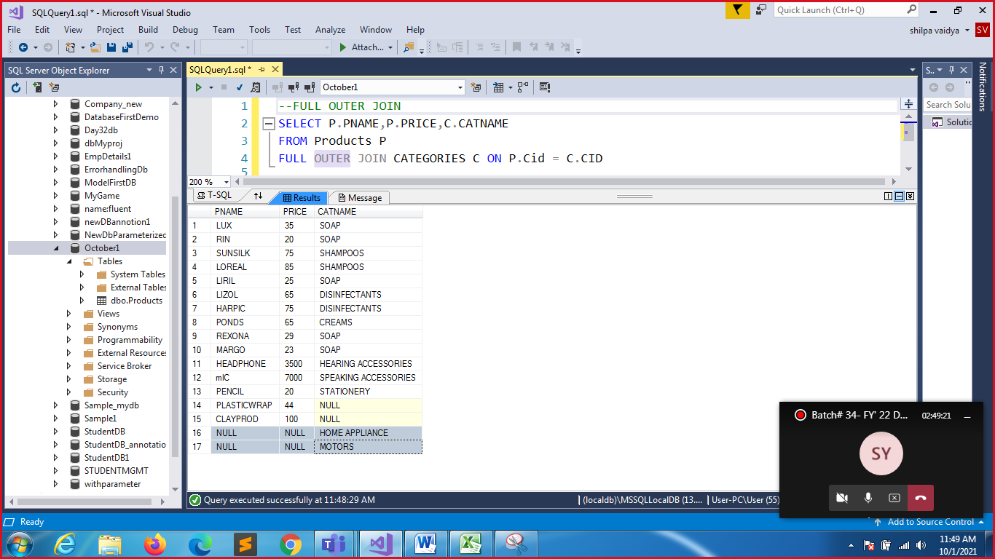

-- TO PROVIDE FEW SELECTED COLUMNS OF PRODUCTS TO NEWPRODUCTS TABLE

-- THAT HAS MATCHING COLUMNS PNAME AND PRICE CREATE THE TABLE BEFORE INSERTION

CREATE TABLE NEWPRODUCTS

(

PNAME VARCHAR(50),

PRICE FLOAT

);

--SELECTED ENTRIES WRT PRODUCTS WILL BE DUMPED INTO THE NEWPRODUCTS(7 RECORDS)

INSERT INTO NEWPRODUCTS(PNAME,PRICE)

SELECT PNAME,PRICE FROM PRODUCTS WHERE PID<=17

SELECT * FROM NEWPRODUCTS;

--ADD FEW EXTRA RECORDS THAT IS THERE IN NEW RECORDS BUT NOT IN PRODUCTS

INSERT INTO NEWPRODUCTS VALUES('WHEEL',35)

INSERT INTO NEWPRODUCTS VALUES('CUSHIONS',88)

|  |  |
| --- | --- |
| PNAME | PRICE |
| LUX | 35 |
| RIN | 20 |
| SUNSILK | 75 |
| LOREAL | 85 |
| LIRIL | 25 |
| LIZOL | 65 |
| HARPIC | 75 |
| WHEEL | 35 |
| CUSHIONS | 88 |
|  |  |
| NEWPRODUCTS | |
|  |  |
|  |  |

--UNION OF DATA WITH THE MATCHING COLUMN NAMES

SELECT PNAME,PRICE FROM Products

UNION

SELECT PNAME,PRICE  FROM NEWPRODUCTS

|  |  |
| --- | --- |
| PNAME | PRICE |
| CLAYPROD | 100 |
| CUSHIONS | 88 |
| HARPIC | 75 |
| HEADPHONE | 3500 |
| LIRIL | 25 |
| LIZOL | 65 |
| LOREAL | 85 |
| LUX | 35 |
| MARGO | 23 |
| mIC | 7000 |
| PENCIL | 20 |
| PLASTICWRAP | 44 |
| PONDS | 65 |
| REXONA | 29 |
| RIN | 20 |
| SUNSILK | 75 |
| WHEEL | 35 |

